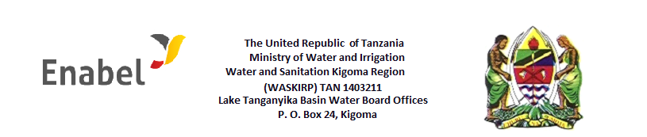

CALL FOR APPLICATIONS FOR CONSULTANCY SERVICE

The Kingdom of Belgium through Enabel and the Government of Tanzania through the Ministry of Water, are implementing a water and sanitation project in Kigoma region. This is a 5-year project which runs through June 2022 and aims to promote provision of sustainable water supply services in the region. This intervention has three key result areas namely: 1) sustainable water supply operations and maintenance, 2) water supply scheme rehabilitation and extension and 3) promotion of safe hygiene practices in domestic water management. Under the first result area, the Water and Sanitation Kigoma Region Project (WASKIRP) is now inviting applications from suitably qualified individuals to provide professional support to the project in establishing and developing community-based water supply organizations (CBWSO), pursuant to the Water Supply and Sanitation Act (No. 5 of 2019).

Main objective of the assignment: Working with the Rural Water and Sanitation Agency (RUWASA), facilitate the establishment of 6 community-based water supply organizations and build the capacity of these to operate as professional entities in managing the operations of their respective water supply schemes.

Specific objectives: There are five specific objectives (each with a set of tasks to be accomplished) to this assignment as follows:
- Through a participatory process, establish and register CBWSOs, one in each of the 6 rural districts of Kigoma.
- Facilitate establishment of operational systems and develop the CBWSO members’ capacity to manage them.
- Working with RUWASA District Managers, analysis of financial requirements of schemes and support setting up of tariff guidelines and revenue collection system.
- Support RUWASA in developing a system for monitoring, evaluation, accountability and learning for the CBWSOs.

Duration: The assignment is for 120 days spread across a one-year period beginning as soon as possible.
Location: The assignment will be carried out in Kigoma Region, and so the consultant, if not Kigoma-based, shall be prepared to travel back and forth from their base; travel arrangements shall be agreed upon.

Qualifications: The consultant shall have the following qualifications
- A graduate (Master degree level) in social and economic sciences, and/or equivalent
- A minimum of 10 years of practical experience in community work in social development projects including water, sanitation and hygiene projects
- At least 5 years working with community-based organizations and NGOs in areas of institutional strengthening and capacity building at local government level;
- Proven experience in facilitating training workshops, coaching and nurturing newly established partnerships
- The successful candidate will provide a traceable record of relevant experience in establishing community-based including cooperative societies, community-based organizations (CBOs), Water User Associations or Community water boards or local NGOs particularly those related to water supply/WASH, public health or small-scale business entities.

Method of application and details of this consultancy are available at: https://btctanzania.wordpress.com/

